CSA2002 – Introduction to Drone

1. Drone and its mission based types.
A drone is a flying robot that can be remotely controlled or fly autonomously using software-controlled flight plans in its embedded systems, that work in conjunction with onboard sensors and a Global Positioning System (GPS).
Based on missions, drones are classified into
Combat: Attacking in the high-risk missions are called as Unmanned Combat Aerial Vehicle (UCAV). It
carry missiles for the missions.
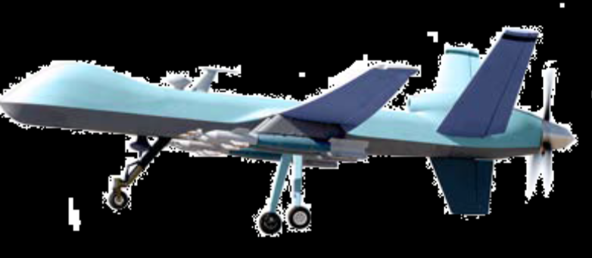
Logistic: When traffic on the roads or the route is not easy to drive. Delivering goods or cargo.
Amazon and Domino’s.
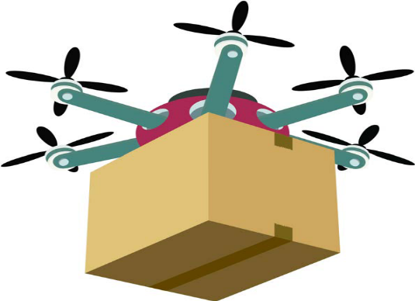
Civil: These drones are used for general purpose such as monitoring the agriculture fields, data
collection, and aerial photography.
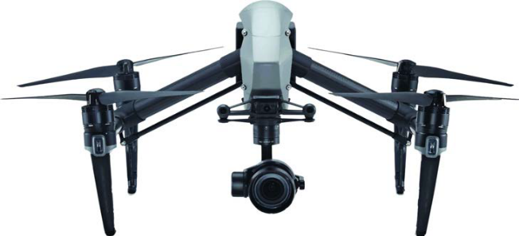

Reconnaissance: This kind of drones are called mission-control drones. It automatically done the assigned work and returns to the base by itself. The size of the drones are small and easy to hide.
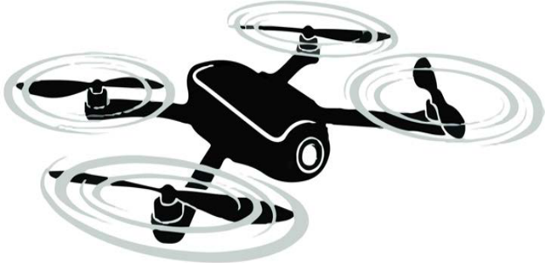
Target and Decoy: These kind of drones are like combat drones. It provides the ground and aerial gunnery with a target that simulates the missile or enemy aircrafts.
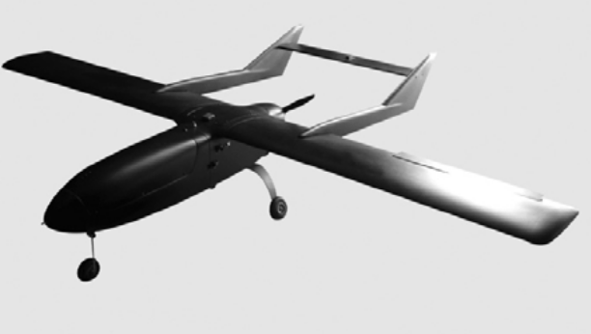

Research and Development: These drones are used for collecting data from the air like weather data.

Drone types based on Wings

There are three types of drones depending on their wings or flying mechanism.

Fixed Wing:
It looks like airplanes.
Having good battery life.
Only one motor.
Fly on high altitude.
Carry more weight because they can float on air for the wings.
The drones are expensive and require a good knowledge of aerodynamics.
Launching and Landing are very difficult, so it need good training.

Single Rotor:
It looks like helicopter.
Propeller design helps to Hover and Change directions.
It can Hover vertically in the air.
Consumes less power, so good battery life.

Multirotor:
It can be classified based on the number of wings – tricopter, quadcopter, hexacopter,
octocopter.
Quadcopter is the most common used multicopter.
Easy to control.
Good payload delivery.
Can take off and land vertically, almost anywhere.
Based on the number of motors, the power consumed from battery.

Multirotor Drones Types based on their Body Structure

The multirotor drones are known by the number of propellers used on them.

Ready to Fly (RTF)
Do not require any assembly of the parts after buying.
User can directly fly the drone.
No complex setup or programming knowledge required.

Bind N Fly (BNF)
If the drone do not come with a transmitter, then another drones transmitter can be bind
with the new drone and fly it.
Experienced flyers had the transmitter to test with other drones.

Almost Ready to Fly (ARF)
Few parts of the drone not assembled.
User assemble them using manuals and fly it.

2. Working principles of components required in Drone.
ECS, FC, Propellers, Battery, GPS, Transceiver, Camera, Sensors, Accelerometer, Altimeter.
3. If you want to build a copter or a glide, first need to decide what frame will buy or build. So,
Based on the frame types, different drones and its thrust value.
- Listing frame materials
- General equation of Thrust
- Drone types based on frames
- For each drone type calculation of Thrust
- Describing Pros and Cons of each drone types

4. Bind Range Test Button.
The assembly of the drone connection is tested using Bind Range Test Button.
Connection:
After assembled the drone, to provide the power to it by connect the battery to the ESC. The ESC will make a beeping sound and the RC receiver show a LED blinking.
Testing:
Press and hold this button until LED of the RC receiver stop blinking. Suppose if the LED is not stop blinking then try switch off or disconnect the binding cable from the RC receiver.

5. Derive the equation of different forces and movements of quadcopter.
Quad = 4 propellers ➔ 2 for Clockwise and 2 for Anticlockwise rotation.
Torque (Tau): The capability of rotating an object around a fixed axis.
Mathematically torque is a vector product of force (F) and the distance (r) of the axis.
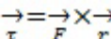 or 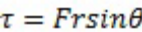
Where, tau is the angle between force and the distance from the centre of
the axis.
(a) Thrust: It is simply pushing something suddenly or with propulsive force. It defined as the
forward force that impels it to go faster or keeps it going in the intended direction.
Mathematically thrust is the product of pressure (P) and area (A).
Thrust = P x A.
The weight of the drone W = mg.
From Newton’s second law of the motion,
Force = mass x acceleration (linear)
The torque = Inertia x acceleration (angular)
(b) Hovering:
The weight of the drone must be equal to all the upward forces of the propellers, where the movement must be equal to zero:
mg = F1 + F2 + F3 + F4
For flying, the upward force must be greater than the weight.
The motion of the drone flying = Upward Forces of the propellers – Mass of the Drone
Df = F1 + F2 + F3 + F4 – mg
(c) Rising / Climbing / Taking off:
To fly the drone over the ground, the forces will be applied to take over the drone is greater than the drone weight. Therefore, the force needed to fly the drone is:
mg < F1 + F2 + F3 + F4
(d) Dropping / Descent / Falling:
The situation of not flying drone, if the weight is more than the upward forces (Df < 0)
mg > F1 + F2 + F3 + F4
Df = F1 + F2 + F3 + F4 – mg < 0
(f) YAW:
The motion of the drone in xy plane or horizontal plane is called Yaw.
Difference movements between any pair of propellers, then it will create Yaw motion, and the drone will move.
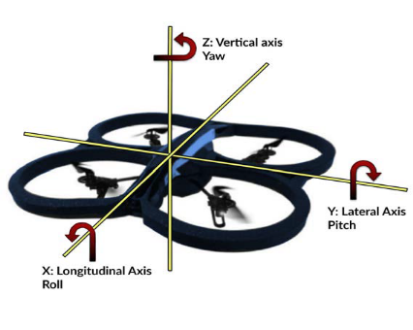
If the drone simply rotates along the Z direction, it is known as a Yaw motion.
If there is a stable upward force and the propeller forces are:
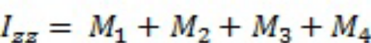
Where, M1, M2, M3, and M4 are the movements of the propellers.
(g) Pitch and Roll:
The pitch is the rotation of the drone in the Y direction.
The roll is the rotation of the drone in the X direction.
OR vice versa depending on the front of the drone.

6. Assemble a drone frame from HobbyKing (S500).
HobbyKIng-S500 Components are:
- Frame arms – 4
- Leg Plates – 4
- Rod for the base mount – 2
- Top Plate – 1
- Bottom Plate – 1 (for mounting the power lines)
- Screws – requirable

Connection Methods:
- Motor Mounting with ESC
- ArduPilot Connections
- Common Power Modules
- Connecting Battery and Testing

7. Building the mission control drones.

- Introduction about mission control drones
- List out the requirements
- Surveying with MissionPlanner
- WayPoint File Creation using Map.
- Usage of RTL option.
- Load the Mission to ArduPilot
- Usage of Flight Mode.

